# 1、 Environment

USB Keyboard

USB Mouse

DisplayPort Display(connecting to monitor)

KR260 Board

Pca9685 Board

Arduino uno Board

6V lithium battery

# 2、Hardware

## 2.1、Skill hand -3D- model

Building 3D Models in SolidWorks.

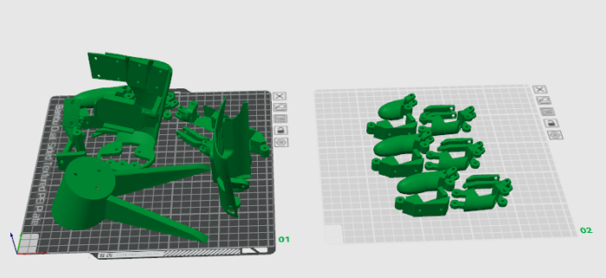

Figure 2.1 3D printing structural components

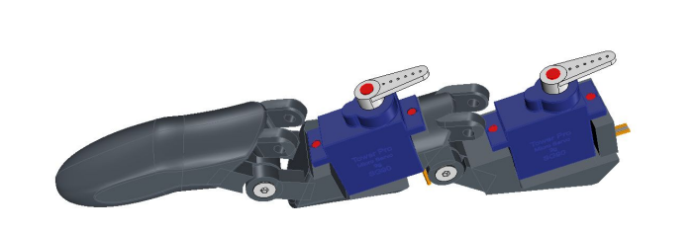

Figure 2.2 Finger joints and servo motor SG90

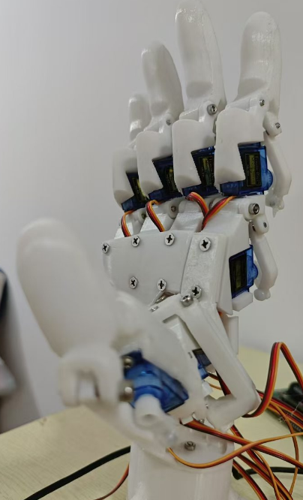

Figure 2.3 Skill hand mechanical structure and servo motor system

## 2.2、Servo motor control system

The servo motor control system consists of 11 servos motor, and the signal lines of the servos motor are interconnected with the PCA9685 board,and software driving provided by Arduino.

Each finger is controlled by two servos motor, and the control process of the servos motor is completed by driving the PCA9685 through Arduino board. The wiring between the PCA9686 control board and the servos motor is shown in the figure 2.4. The upper part of the servos motor for each finger is numbered 0, and the second part is numbered 1, the corresponding relationship between the servos motor and the interfaces on the PCA9685 board is as follows:

The number of the thumb is 0, and the numbers of the two servos motor are 0_0 and 0_1,

The index finger is numbered as 1, with 2 servos motor numbered as 1_0 and 1_1,

The number of the middle finger is number 2, and the numbers of the two servos motor are 2_0 and 2_1, respectively,

The number of the ring finger is number 3, with two servos motor numbered 3_0 and 3_1,

The number of the little finger is number 4, with two servos motor numbered 4_0 and 4_1,

The corresponding relationship between the servo and the interface on the PCA9685 board:

0_0 (0), 0_1 (1), 1_0 (2), 1_1 (3), 2_0 (4), 2_1 (5), 3_0 (6), 3_1 (7), 4_0 (8), 4_1 (9), 5_0 (10)

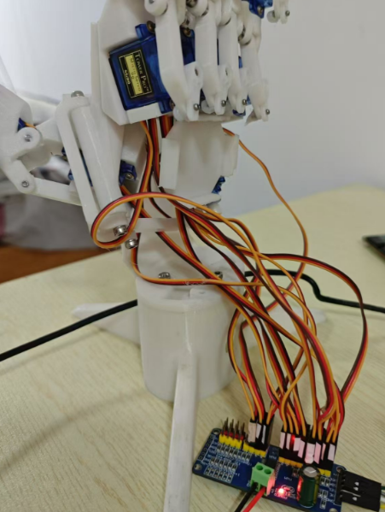

Figure 2.4 Skill hand mechanical structure and servo motor system

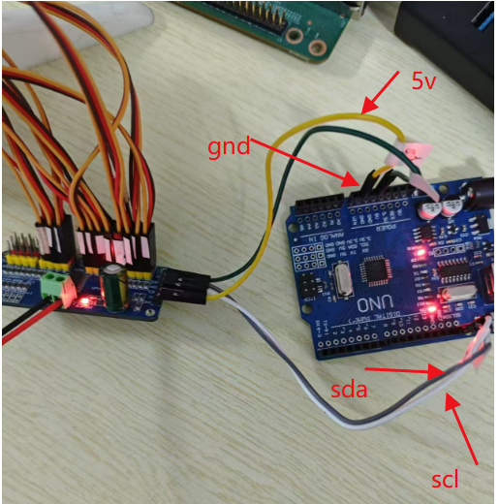

Figure 2.5 The connecting between Pca9685 board and Arduino uno board

## 2.3、Serial communication

Kria KR260 FPGA board and Arduino uno board build serial communication, based on this communication gesture recognition results are transmitted to the multi-level driver board.

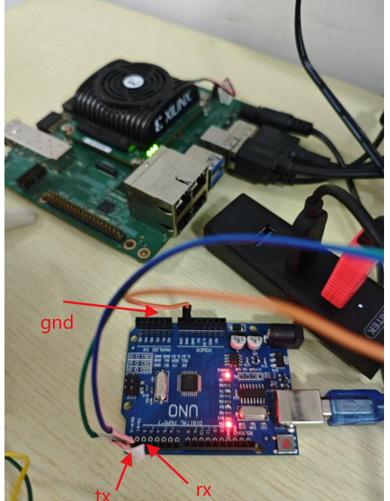

Figure 2.6 The connecting between KR260 board and Arduino uno board

## 2.4、The whole system control

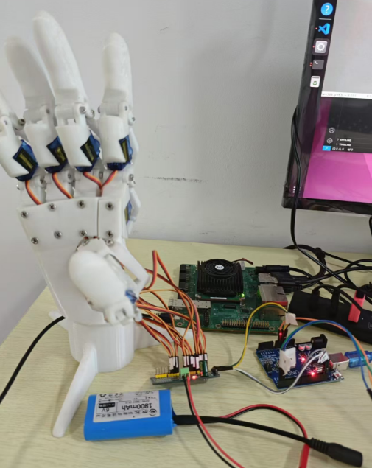

Figure 2.7 The whole system control structure

# 3、Software

## 3.1、Gesture Recognition process

Using a USB camera to capture video stream data, and Model-based Reasoning application using Kria KR260 FPGA board. By detecting 21 key points on the hand, the features between the edge of the skill hand and the convex hull are obtained, and the corresponding gesture results are judged based on the features of different gestures,The gesture recognition results support six gestures, namely "1" - "2" - "3" -4 "-" 5 "-" good ". The process of gesture inference and calculation relies on opencv and mediapipe. If you want to end the gesture recognition processing, use the q key on the keyboard to exit(software path: src\opencv\hand_feature_serial.py). Demo test result:

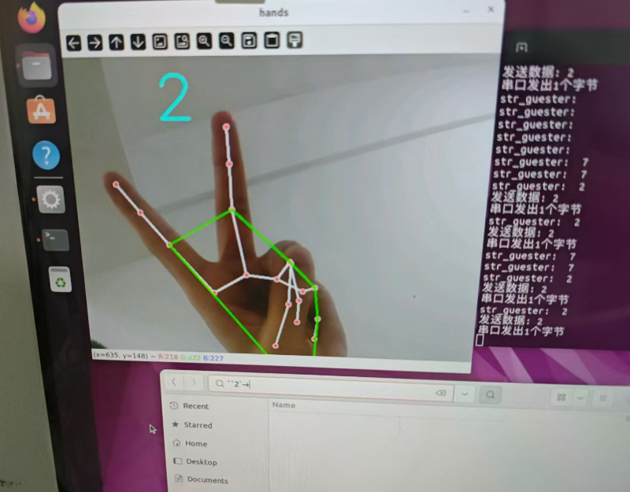

Figure 3.1: Gesture recognition process

## 3.2、Serial transimtition and servo motor control

Servo motor control process is designed in ardunio IDE. The gesture recognition results are transmitted through the serial port to ardunio uno board and control pca9685 board, The software control system drives the servo to rotate at different positions based on different gesture results(software path: src\Servo_proj\Servo_proj.ino).

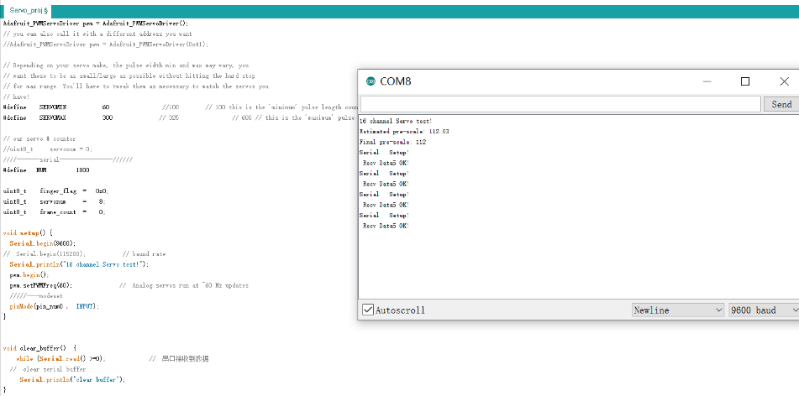

Figure 3.2 Serial transimtition and servo motor control